**P6- configure a computer system to meet user needs**

In this assignment, I will be showing you the guides of the following:

* BIOS configuration e.g. setting BIOS password
* Editing power management options
* Editing anti-virus confirguration
* Editing the desktop e.g. icon size
* Setting file sharing/permissions
* 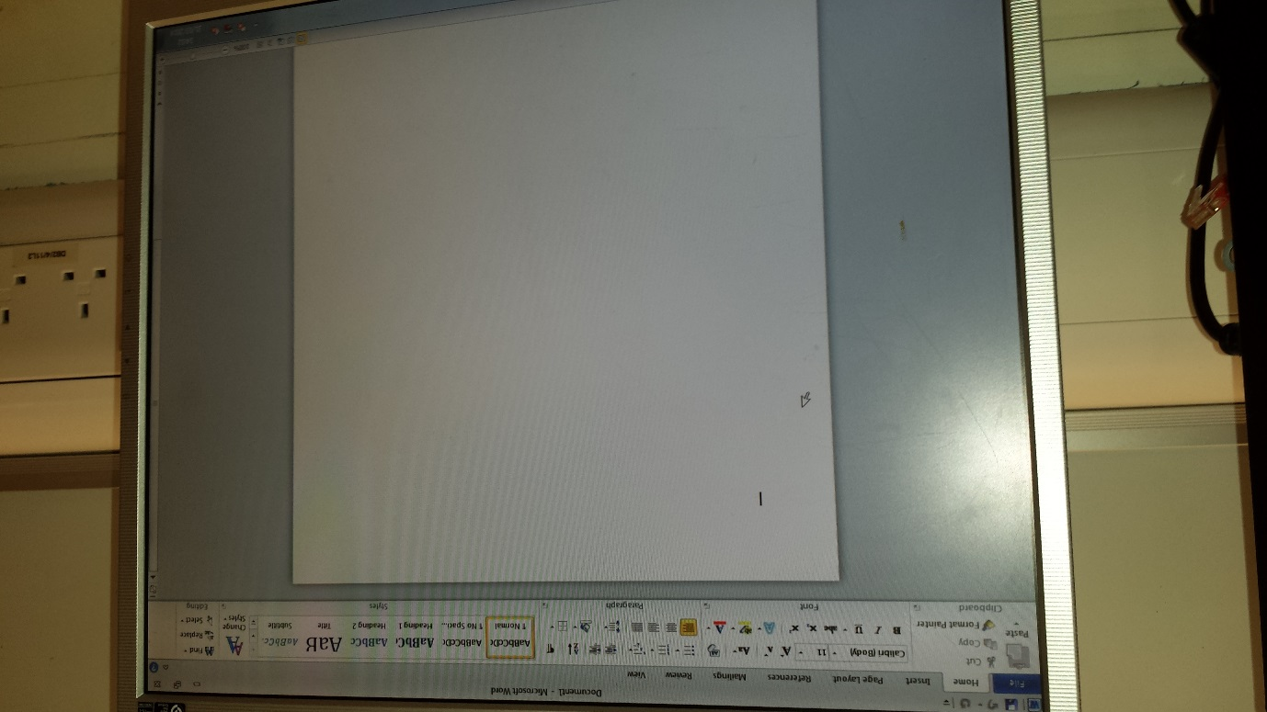Creating and reconfigurating application toolbar

We followed the steps from the bottom to the top. The first task that was set is creating and reconfirgurating application toolbar. We used Microsoft Word for this task. We will complete this task as it would be easier for the user to use the tools.

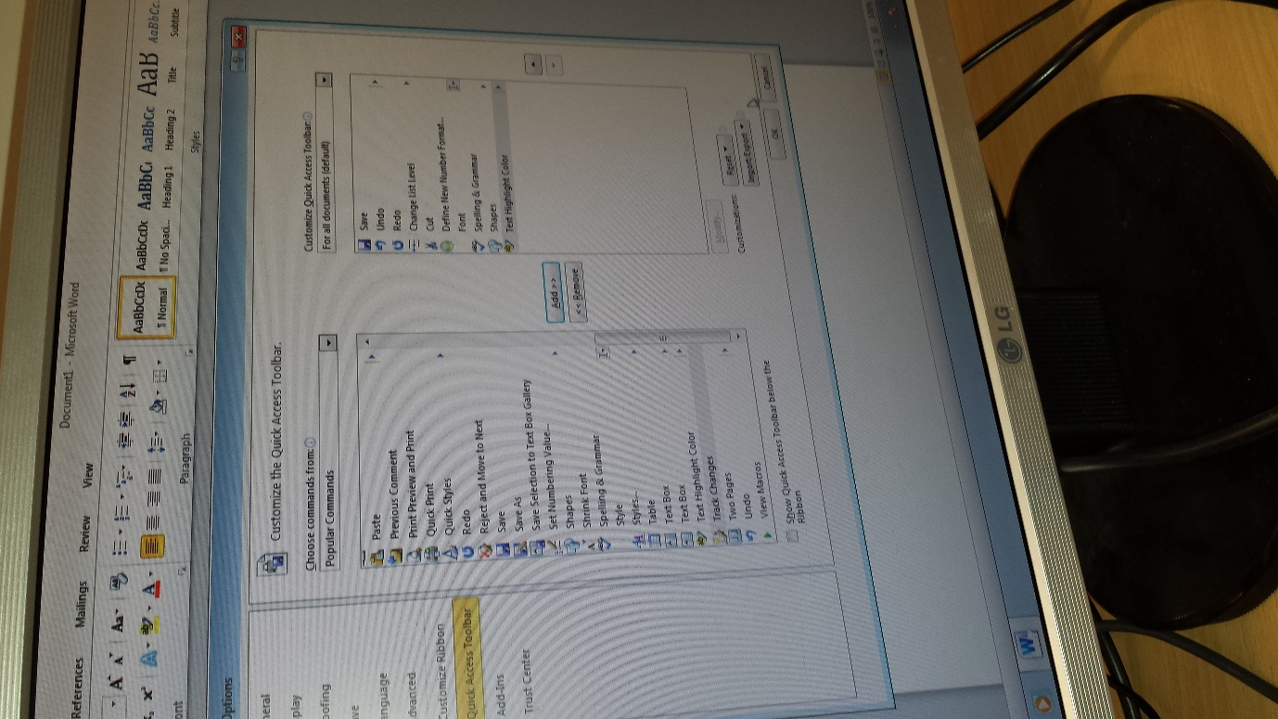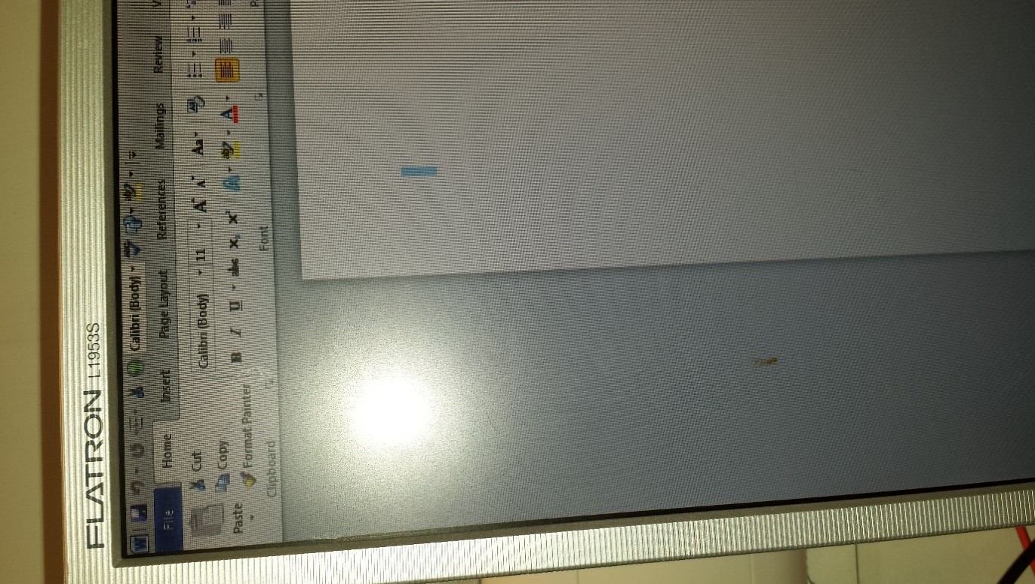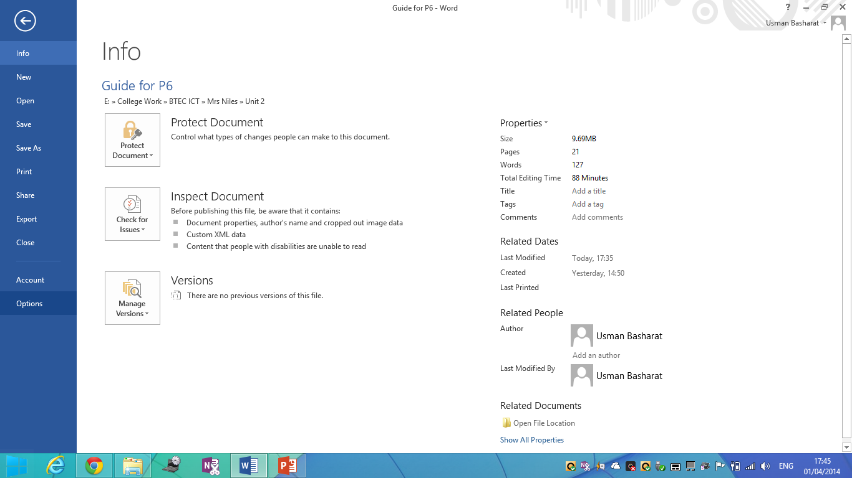As it demonstrates on this image, we will be working on the toolbar of Microsoft Word. Firstly, you would need Microsoft Office. Without this, you cannot complete this task. Go on ‘File’ and ‘Options’. Go on ‘Quick Access Toolbar’ as it would show you could customise the toolbar. You can add/remove the present features that have been added. It makes it easier for the user to use. You could customise the toolbar and choose which ones you would like to have on there. Once you have completed this task, click ‘OK’ and the process is complete. As you can see on the image, I have placed some examples that I think it would make it easier for me. It would look something like the following image.

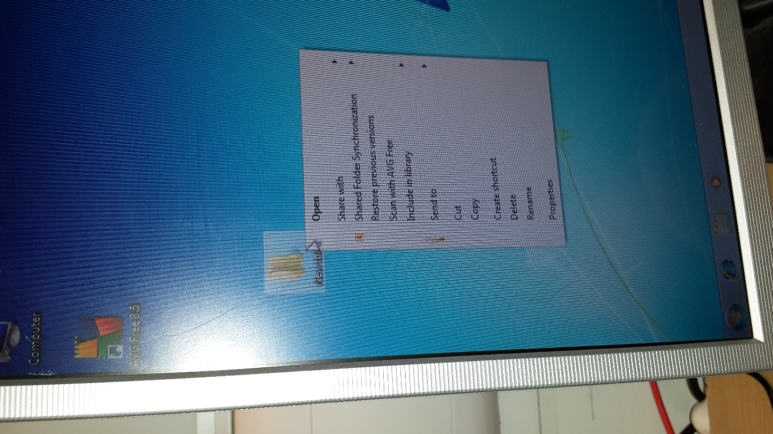This part, I will be presenting to you you how to make your documents private and who can have access to it. You have to put the document into an folder as it is easier to do it this way. Once you have done it, place it on the desktop and click on the properties. You will browse to the properties. Here you will need to go on sharing. This is the place where you can choose who can access your documents. Click on the button ‘Share’ and it shows who you can share the document/file with. This is the one way you can set the file permission. Another way is to click ‘advance sharing’ and ‘permissions’. The blue highlighted box gives the permission and how they will access it e.g. read only.

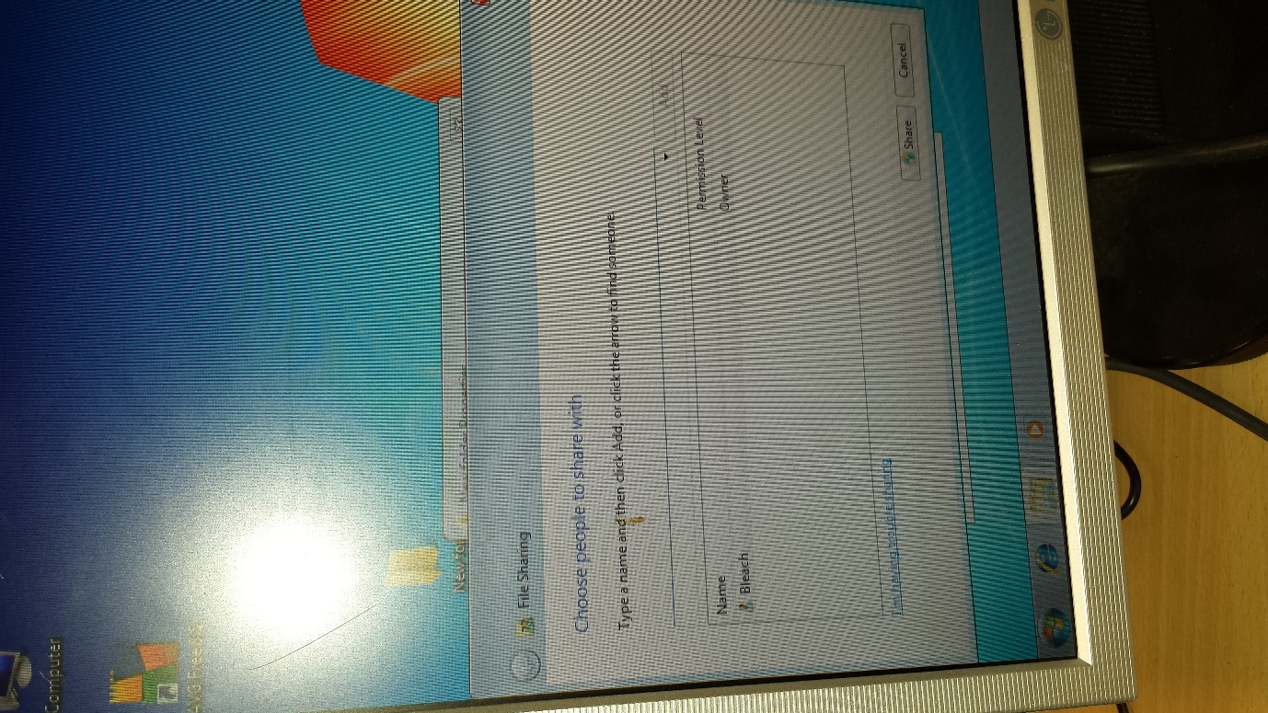

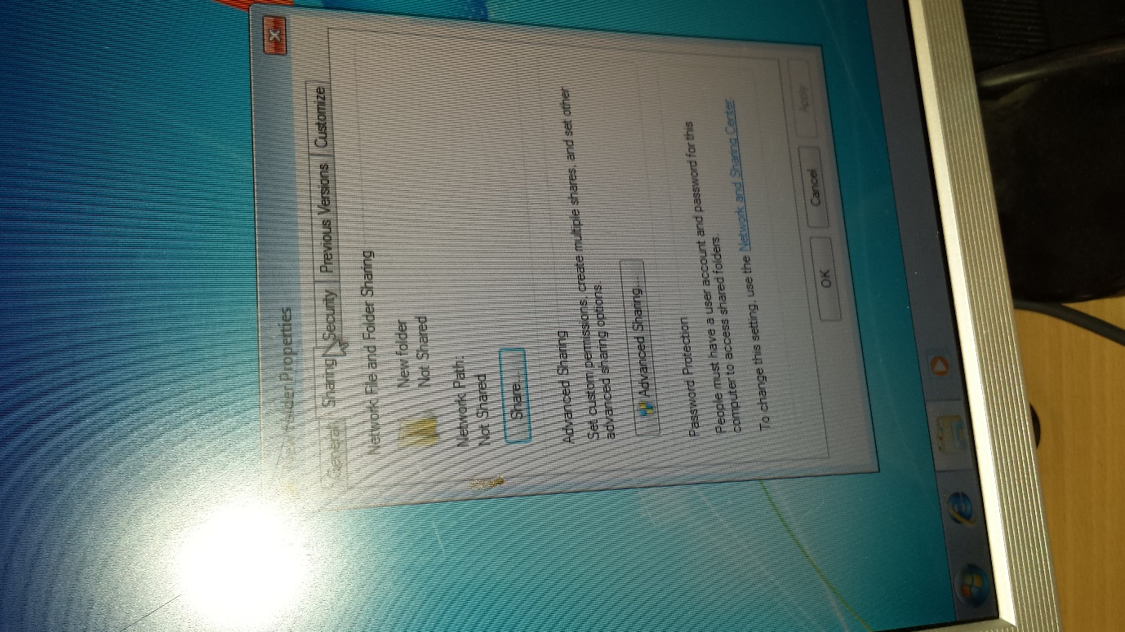

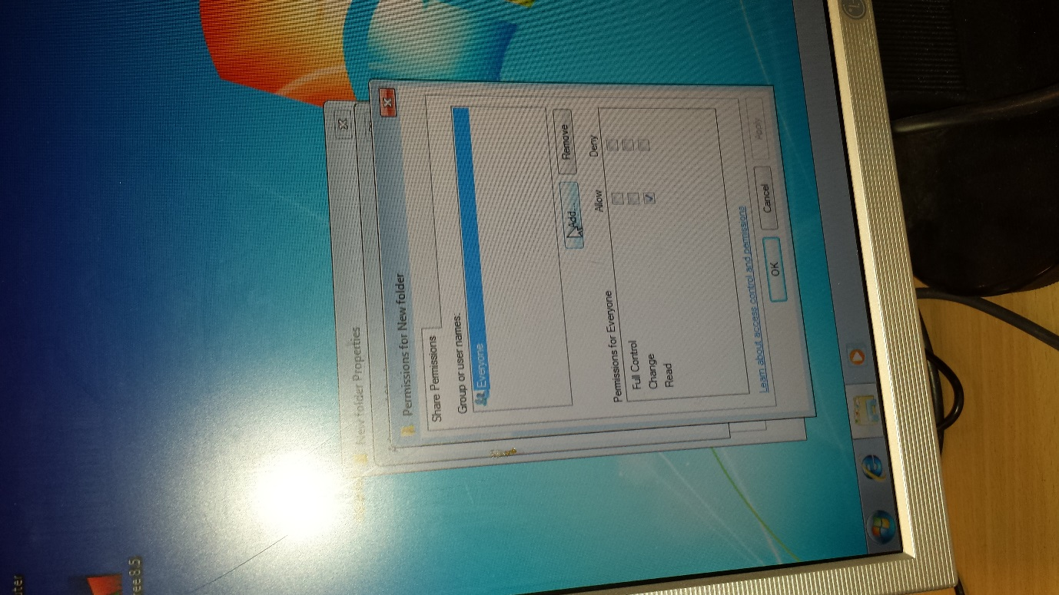

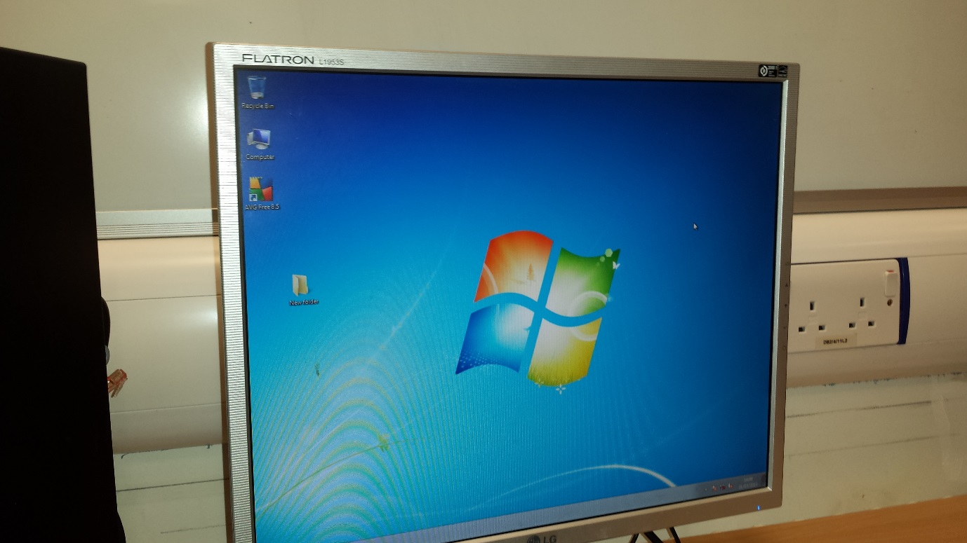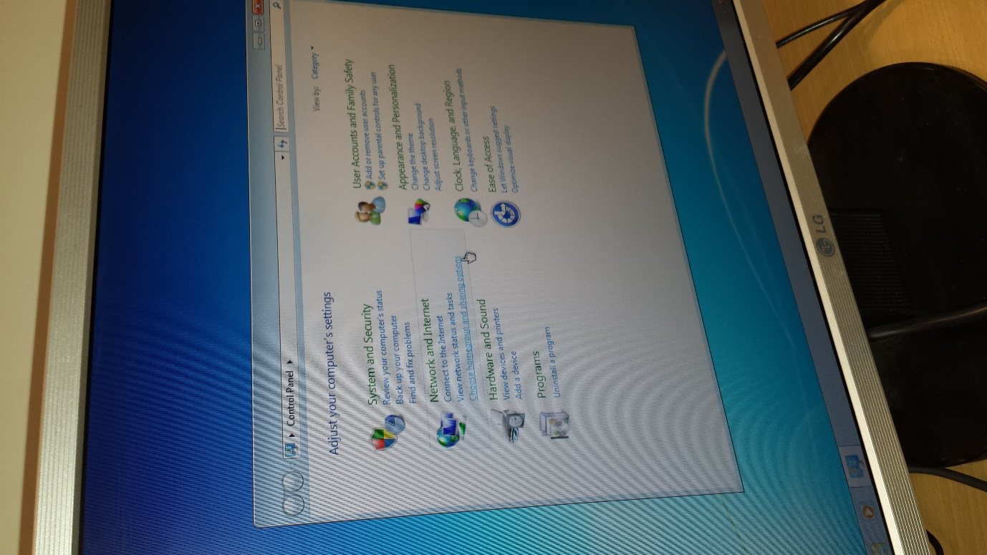

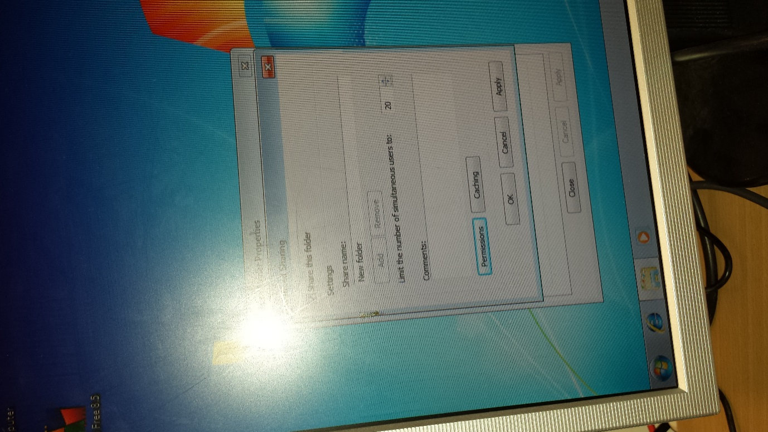

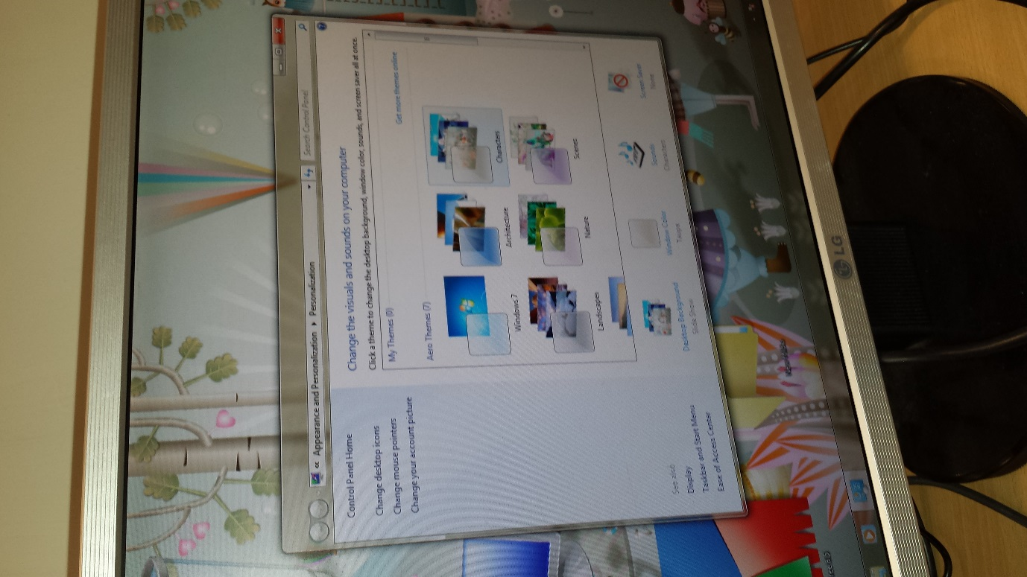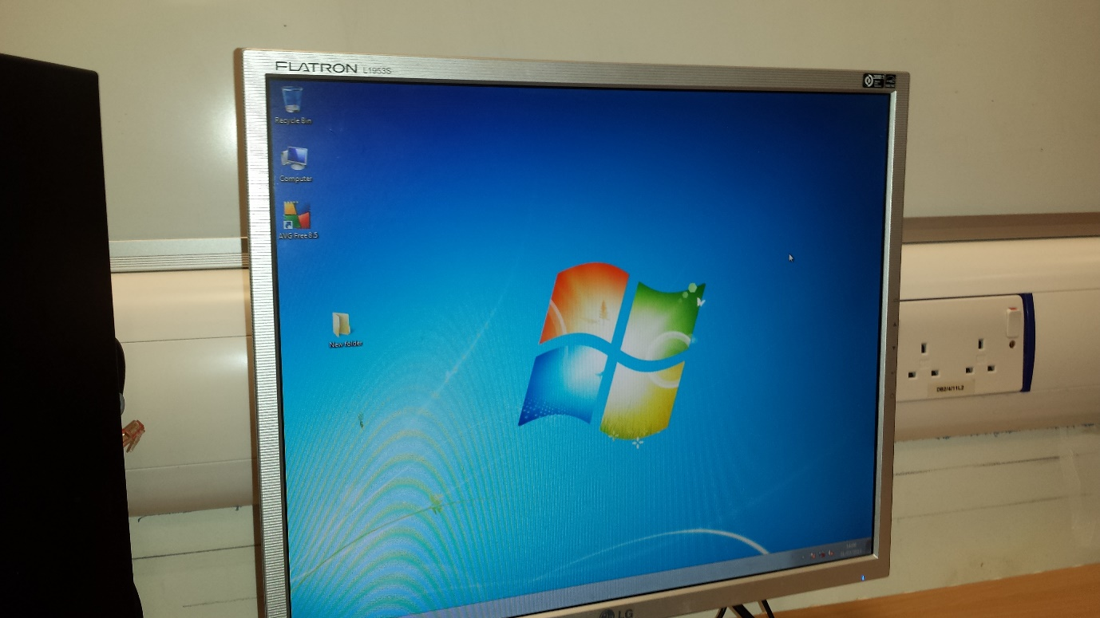I will be changing the desktop. This is easy to do. If you want to make the icons bigger, you will need to press on your keyboard ‘CTRL’, and the scroll on your mouse. It would make it easier for the user to see which application they want to use. Especially old people, they would need the icons bigger to make it easier for them. If you want to change the desktop wallpaper, you will need to right-click on the background and choose which one you like. In addition, you could upload an image as a background.

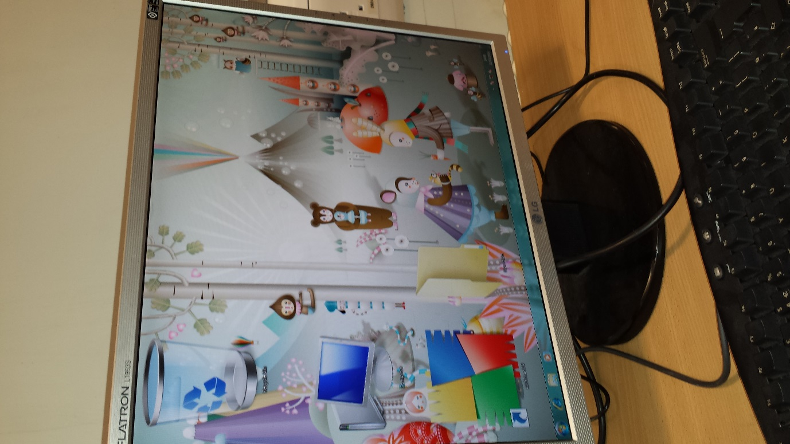

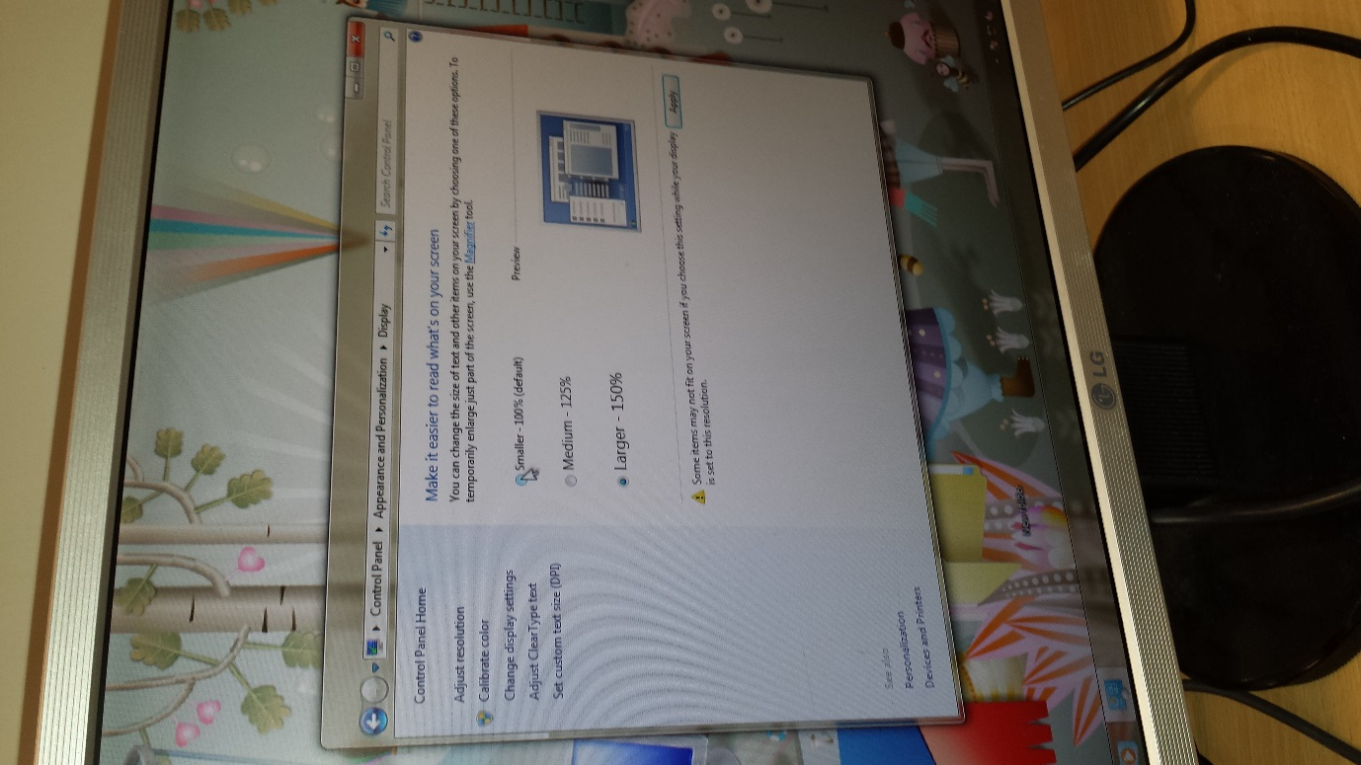If you want to read easier, you will need to go on the Appearance and Personalisation and click Display. As the image shows below, you could make it small, medium or large. It would enable the user to read and make the display much easier.

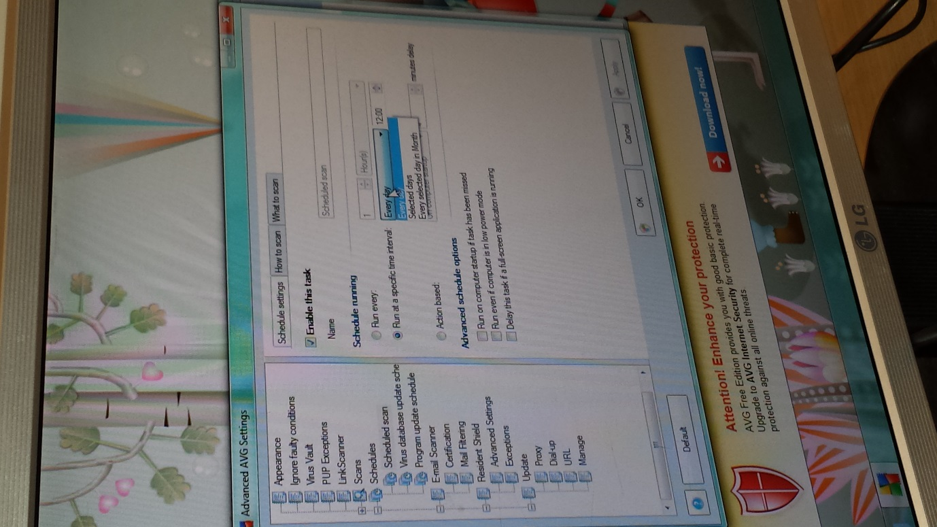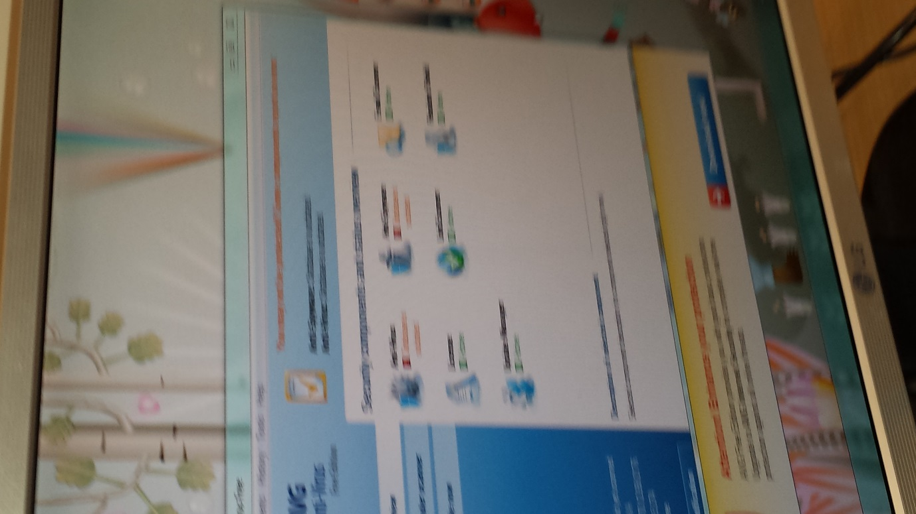In this part, we will make configure with the AVG anti-virus. We will need to go on Tools, Settings and Advance Settings. We will need to make the scan a specific timing for the AVG scan to occur e.g. scan only on Tuesdays. We scheduled the scan by every day and selected days, Monday and Wednesday. The timings is 18:00 (6PM). Once you have followed these procedures, it will scan on the selected time and day.

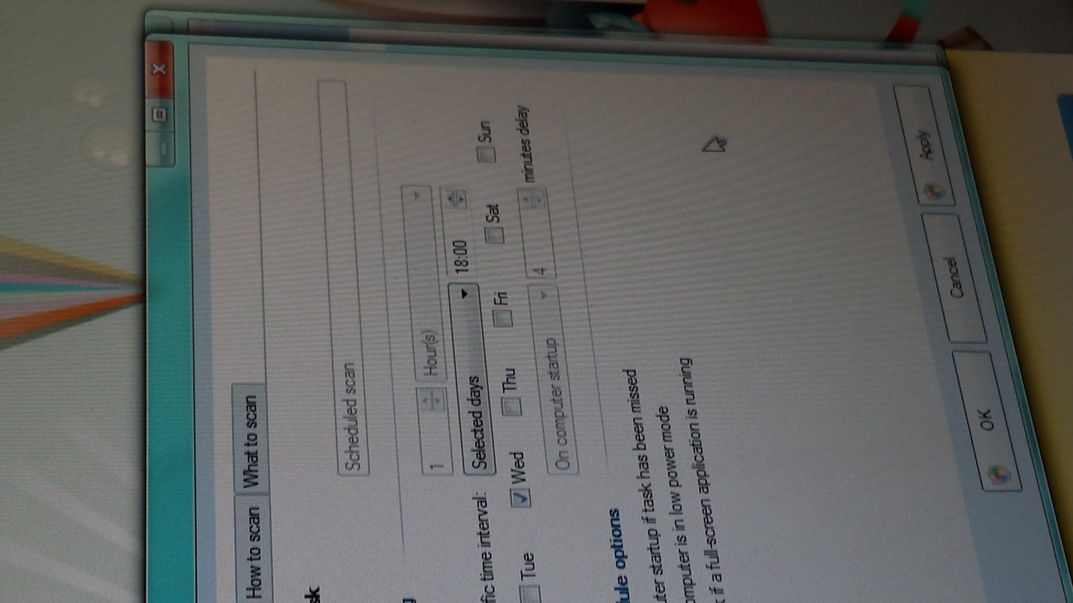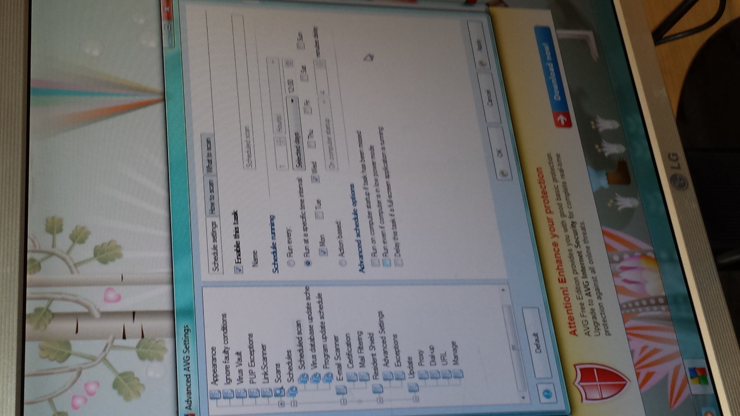

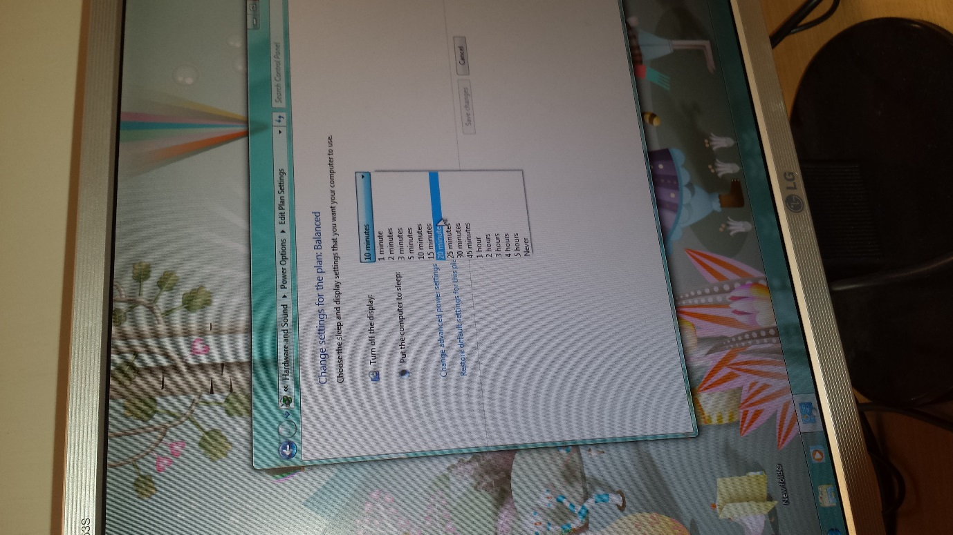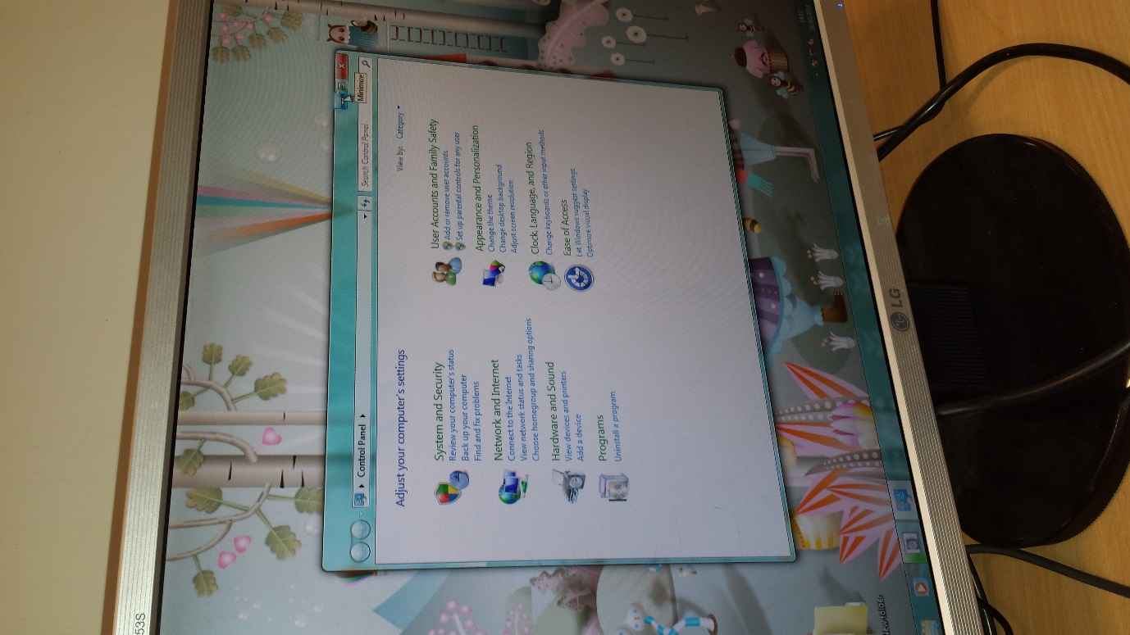Now, we will change the power configuration. We need to go on control panel and the hardware and sound. This is where the power options is selected. You will need to edit your plan settings e.g., after how long the computer turn off will. We turned the display off after 10 minutes and put the computer to sleep after 1 hour. It is much easier for the computer as it would be bad for the computer to be left on all the time. Save the changes once you are done.

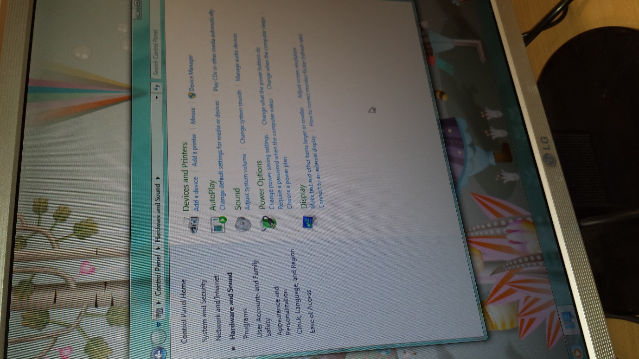

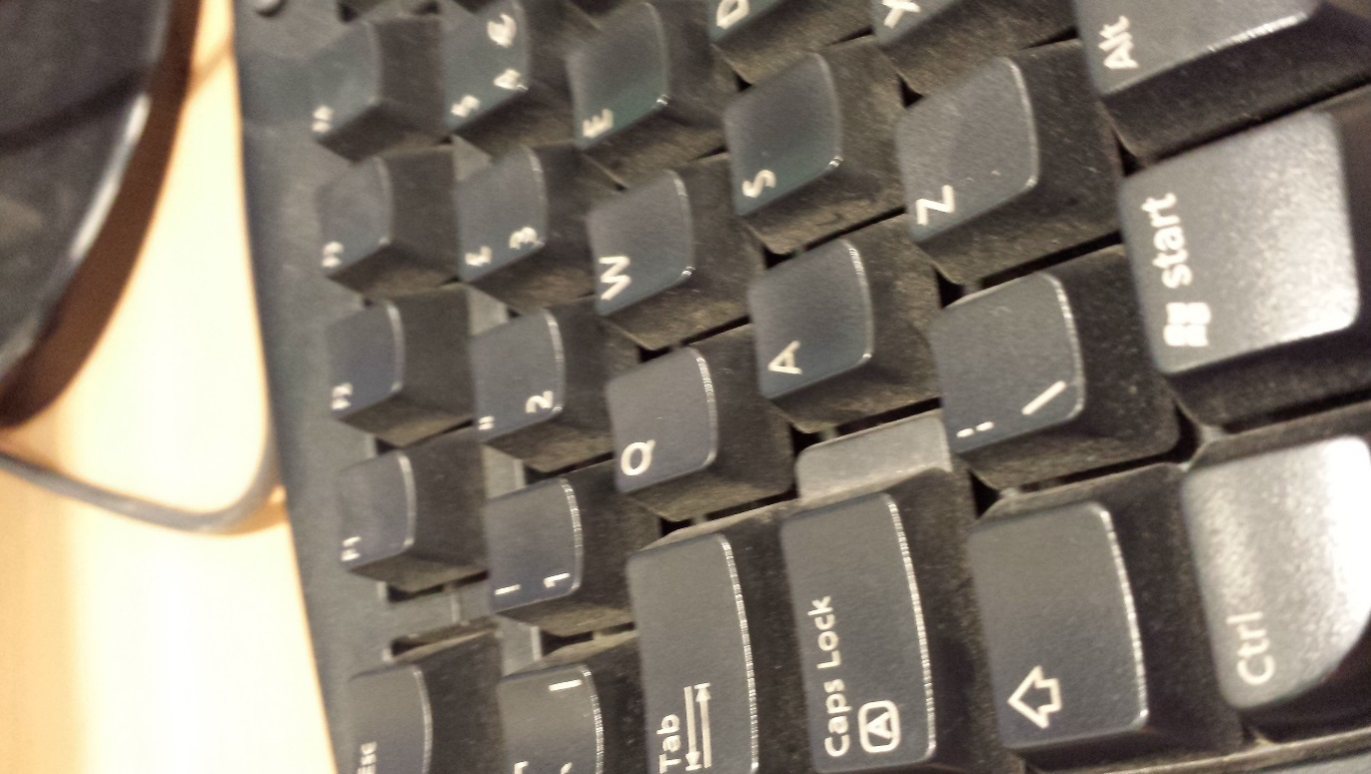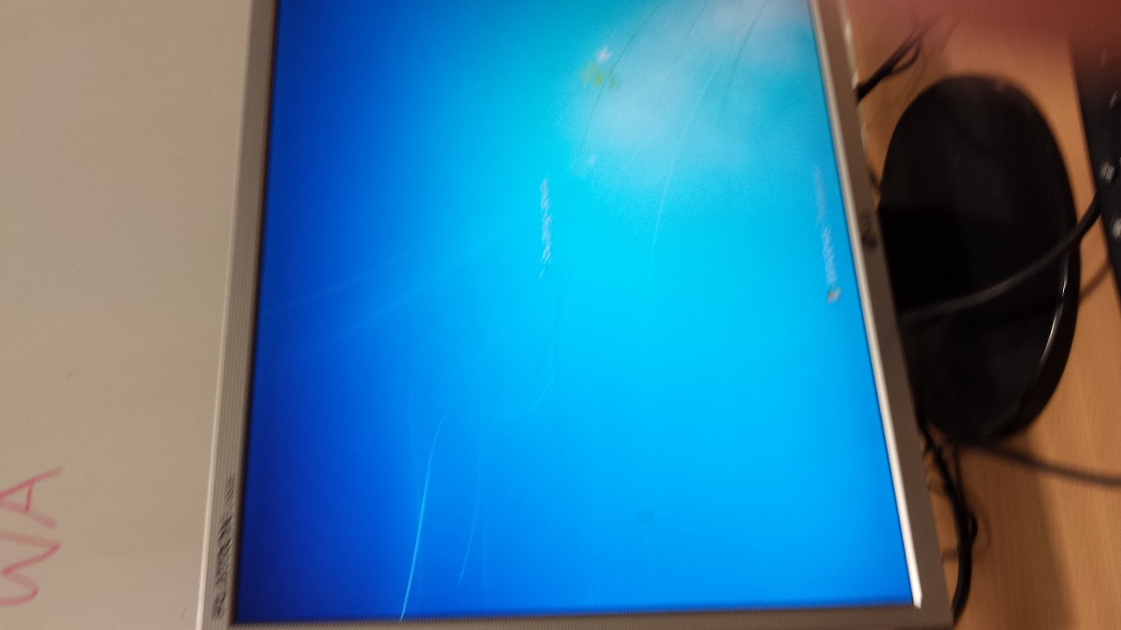Now we will change and remove the BIOS password. We will need to turn off the computer. Once it is turned off, turn it on again and press F2 until you see a blue screen.

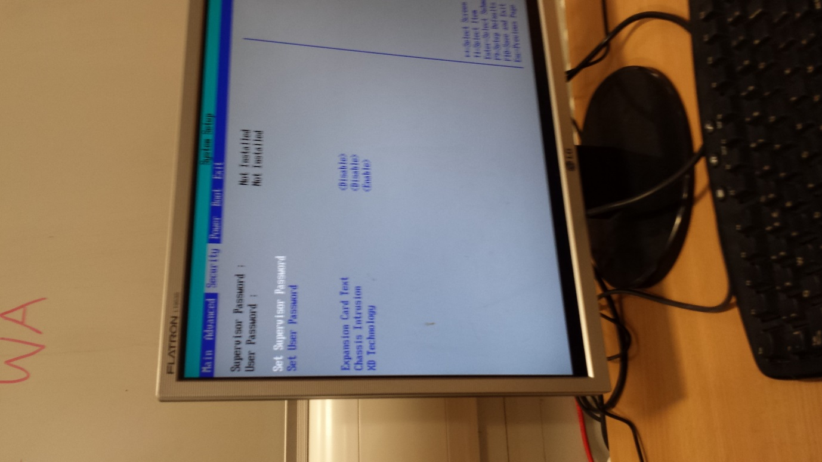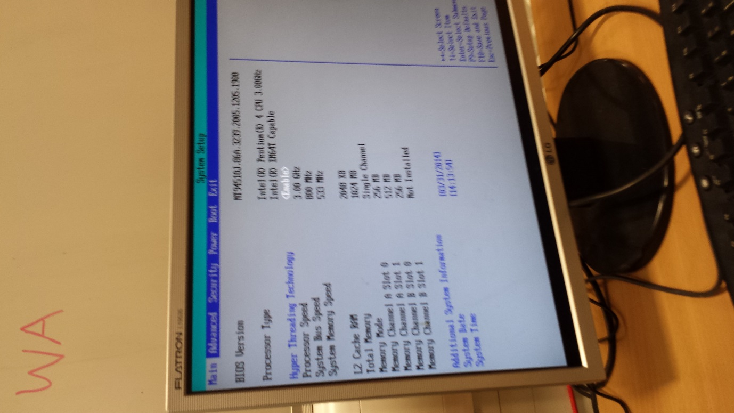Referring to the image below, it will look something like this. Go to security where the BIO password is placed.

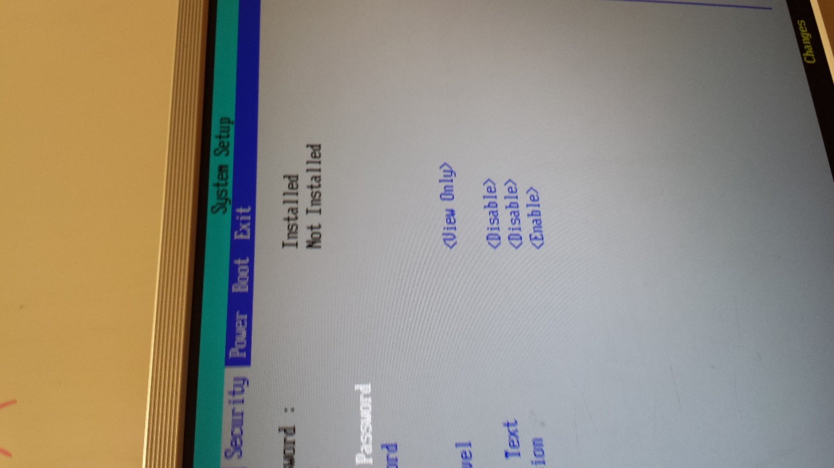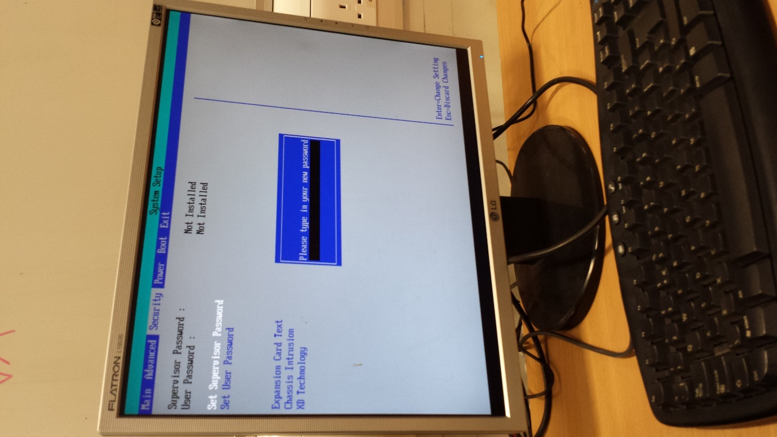As you can see, it says that the password has not been installed. You are looking at the supervisor password. Enter your password and confirm it. It has to say on the supervisor password ‘Installed’. To remove the password, you will need to press enter twice on the set supervisor until it says not installed. Save the changes and you are complete.

